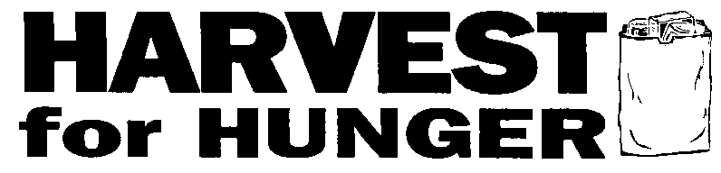

MEDIA ALERT

CONTACT: Karen Pozna, Greater Cleveland Food Bank, 216-738-2132 or cell 216-214-9436

HARVEST FOR HUNGER KICKS OFF ANNUAL CAMPAIGN
WEDNESDAY, FEBRUARY 26 AT 10 a.m.

WHAT: Community leaders will kick off the annual 21-county Harvest for Hunger food and funds drive, which takes place every spring in Northeast Ohio. The drive is one of the largest of its kind in the nation, raising over $4 million, enough for 16.5 million meals in 2013. The campaign is a collaborative effort of four food banks including the Akron-Canton Regional Food Bank, the Second Harvest Foodbank of North Central Ohio and the Second Harvest Foodbank of Mahoning Valley; and coordinated locally by the Greater Cleveland Food Bank.

WHEN: Wednesday, February 26, 10 a.m.

WHERE: Quicken Loans Arena Practice Courts

WHO: 2014 Harvest for Hunger campaign co-chairs are Andrea Hogben, President, Northeast Ohio Media Group, and Howard Lewis, Chairman, CEO and Founder, Family Heritage. Mayor Frank Jackson and Cuyahoga County Executive Ed FitzGerald are serving as honorary co-chairs.

All the co-chairs and honorary co-chairs will be in attendance to kick off the campaign along with Anne Goodman, president & CEO, Greater Cleveland Food Bank, and Jan Ridgeway, Director, Garden Valley, a Foodbank member agency. Hundreds of Harvest for Hunger food drive coordinators, volunteers and supporters will be in attendance. Local media personalities and corporate teams will participate in a shopping cart relay and grocery bagging contest and representatives from local supermarkets will serve as judges.

WHY: Northeast Ohioans are turning to local hunger centers more and more as the need for emergency food continues to increase. Recent cuts to the SNAP program (also known as food stamps) present an additional challenge to the Greater Cleveland Food Bank and hundreds of local hunger relief organizations. Every dollar donated through the campaign provides enough food for four nutritious meals. Dollars raised through Harvest For Hunger are used to provide nutritious food to hundreds of hot meals sites, food pantries, shelters and other agencies in Northeast Ohio. Almost 50% of those served by the Greater Cleveland Food Bank’s 700 member programs are children and elderly. Harvest for Hunger is a critical resource for local hunger centers and the families they serve.

AGENDA: 10:00 a.m. Opening comments
10:05 a.m. Remarks by community leaders listed above
10:45 a.m. Celebrity supermarket challenge

PHOTO OPPORTUNITIES:
- Remarks by community leaders.
- Members of the media and co-chair companies engage in the shopping cart races and compete to see who can pack the best bag of groceries to be judged by supermarket representatives.

Harvest for Hunger supermarket sponsors include Giant Eagle, Heinen’s, Dave’s Markets, Fishers Foods, Buehler’s Fresh Foods and UFCW Local 880. Local media sponsors include Northeast Ohio Media Group, WOIO Channel 19, WKYC TV 3, WEWS NewsChannel 5, WJW Fox 8, KISS FM, WGAR, WMJI, WMMS, The Lake, and WTAM. For more information, visit www.HarvestForHunger.org.
# # #

